**Documentation for deployment of ANN for Park Vector in RaspberryPi 4B**

1. Make sure to install the 64-bit Raspbian OS from the RaspberryPi imager software from windows (custom file install). This is because, the ANN uses TensorFlow and Keras which is supported only by 64Bit operating systems.

**Download 64-Bit OS from this link :** <https://www.raspberrypi.org/forums/viewtopic.php?t=275370>

1. Select Choose OS

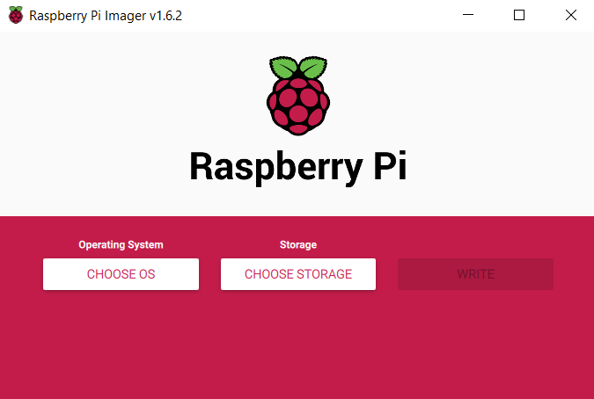

1. Scroll down and select Choose Custom 🡪 Select the OS file that we downloaded from the link --?> Choose storage (SD Card with 16GB > Capacity) 🡪 Write

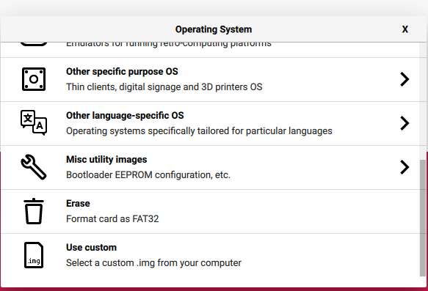

1. Now Connect RaspberryPI to preferred monitor and assemble required peripherals and boot the raspberryPi.
2. Install the Python IDE of choice. For the purpose of documentation, we choose Spyder. This is done by implementing the following code in the terminal of the RPI

**sudo apt-get install spyder3**

This will install the Sypder IDE in RaspberryPi. This can be opened through the “Programming” tab

1. **Installation of TensorFlow 2.5.x in raspberry Pi**
2. Implement the below commands one by one in the RaspberryPI terminal ($ represents terminal commands. Should not be typed in the terminal)

**# get a fresh start (remember, the 64-bit OS is still under development)**

$ sudo apt-get update

$ sudo apt-get upgrade

**# Install pip and pip3**

$ sudo apt-get install python-pip python3-pip

**# Remove old versions, if not placed in a virtual environment (let pip search for them)**

$ sudo pip uninstall tensorflow

$ sudo pip3 uninstall tensorflow

**# utmost important: use only numpy version 1.19.5**

**# check the version first**

$ pip3 list | grep numpy

**# if not version 1.19.5, update!**

$ sudo -H pip3 install numpy==1.19.5

**# install the dependencies (if not already onboard)**

$ sudo apt-get install gfortran

$ sudo apt-get install libhdf5-dev libc-ares-dev libeigen3-dev

$ sudo apt-get install libatlas-base-dev libopenblas-dev libblas-dev

$ sudo apt-get install liblapack-dev

**# upgrade setuptools 40.8.1 -> 57.0.0**

$ sudo -H pip3 install --upgrade setuptools

$ sudo -H pip3 install pybind11

$ sudo -H pip3 install Cython

**# install h5py with Cython version 0.29.23 (± 15 min @1500 MHz)**

$ sudo -H pip3 install h5py==3.1.0

**# install gdown to download from Google drive**

$ pip3 install gdown

**# copy binairy**

$ sudo cp ~/.local/bin/gdown /usr/local/bin/gdown

**# download the wheel**

$ gdown https://drive.google.com/uc?id=158xXoPWOyfNswDTaapyqpREq_CBk1O_G

**# install TensorFlow 2.5.0 (± 68 min @1500 MHz)**

$ sudo -H pip3 install tensorflow-2.5.0-cp37-cp37m-linux_aarch64.whl

1. After installation, check the version as follows.

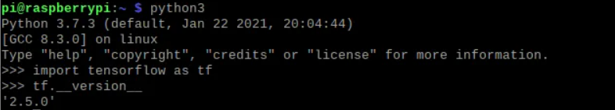

1. **Install Keras in raspberry PI**
2. Input the following commands in Terminal

$ sudo apt-get install libblas-dev

$ sudo apt-get install liblapack-dev

$ sudo apt-get install python3-dev

$ sudo apt-get install libatlas-base-dev

$ sudo apt-get install gfortran

$ sudo apt-get install python3-setuptools

$ sudo apt-get install python3-scipy

$ sudo apt-get update

$ sudo apt-get install python3-h5py

pip3 install keras

pip install keras

1. **Install ScikitLearn / Sklearn**
2. Input the following commands in Terminal

$ sudo apt-get install python3-sklearn python3-sklearn-lib python3-sklearn-doc

1. **Install Matplot.lib**
2. Input the following commands in Terminal

$ sudo apt update

$ sudo apt install python3-matplotlib

1. **Install Pandas**
2. Input the following commands in Terminal

$ sudo apt-get install python-pandas

1. **Run the code provided in your python IDE for deploying the model**